**ERD diagram of Mary Mulcahy Dental Clinic PhpMyadmin Database:**

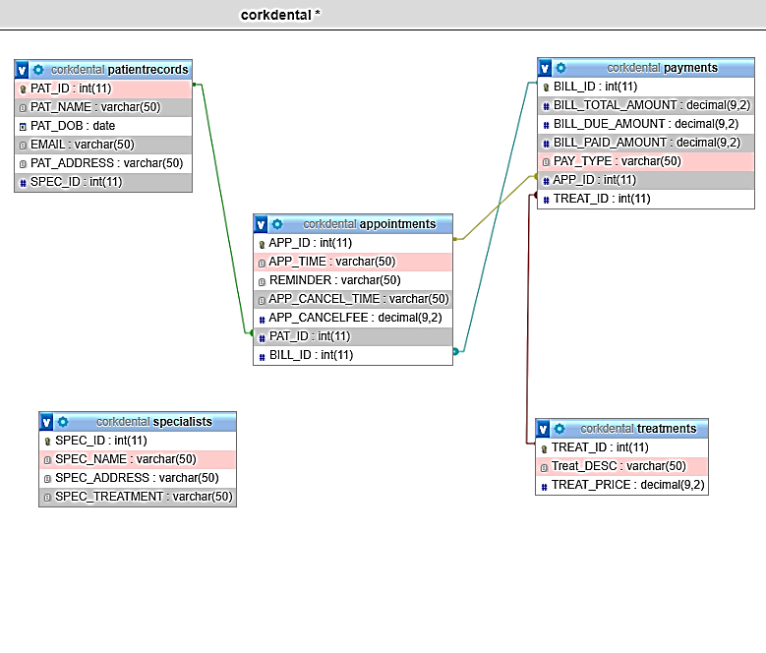

Primary keys are listed as gold icons with the datatype int(11) per table in the corkdental Database. ERD diagram was extracted from phpmyadmin software utilising the trigger module.

-patientrecords table link to appointments table: 1:M relationship between registered patients (PAT_ID) who could have many appointments.

-appointments table link to payments table: M:M relationship because many appointments per patient and patients could pay in instalments. One appointment could have two procedures and result in two payments.

-appointments table link to treatments table: M:M relationship when multiple treatments result in multiple payments.

-It was planned to add the primary to foreign key relationship for specialists SPEC_ID to the patientrecords table. The primary key was made in the treatment table and the need for null values made it difficult to set a constraint for that foreign key. The link between patient table to the specialist table is not routinely required.